z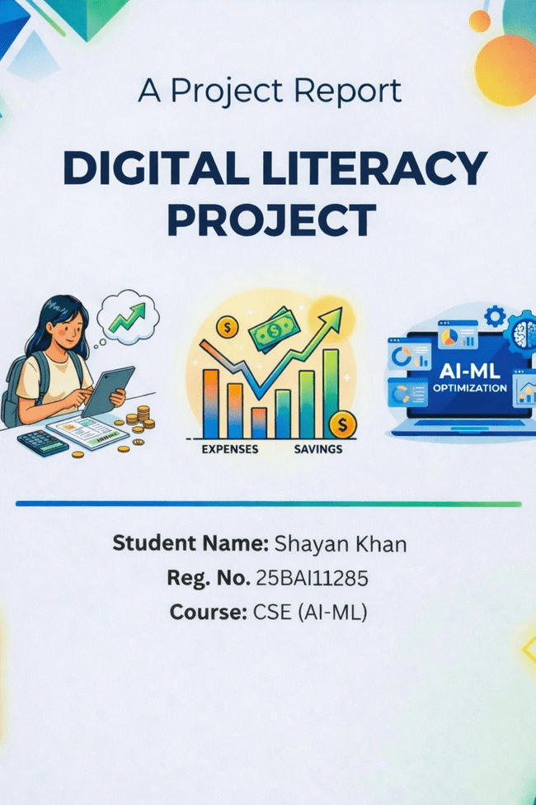Introduction:

Digital literacy is an essential skill in today’s technology-driven world. This project was undertaken to understand the importance of digital tools, online presence, communication etiquette, and cyber safety. As a Student Digital Ambassador, the goal was to create resources that help peers navigate the digital environment effectively and responsibly. Through various tasks, I explored platforms like GitHub and LinkedIn, practised coding, created a digital awareness infographic, and learned about cybercrime prevention. This project not only enhanced my technical skills but also improved my understanding of professional communication and online safety. Overall, it provided practical exposure to real-world digital practices.

Task 1

For this task, I used Canva to create a digital literacy awareness infographic. Canva is an easy-to-use online design tool that provides templates and design elements. My infographic focused on four main topics: what digital literacy is? , safe internet practices, useful digital tools for students, and email etiquette. I included tips like using strong passwords, avoiding suspicious links, and maintaining professionalism in emails.
The design was created using a clean layout with icons and short bullet points to make the information easy to understand. I used different colors to highlight each section and ensure visual clarity.
One challenge I faced was selecting the right amount of content to include without overcrowding the design. It was interesting to learn how visual communication can make information more engaging and accessible. This task helped me understand the importance of presenting information clearly and creatively.

Task 2

In this task, I created profiles on GitHub, LinkedIn, and ResearchGate. GitHub is used to store and share code repositories, LinkedIn is a professional networking platform, and ResearchGate is used for research.

On GitHub, I created a profile README that includes my name, branch, and learning goals. On LinkedIn, I updated my education details with my current degree and institution.ResearchGate will help me explore, research topics and academic work.
These platforms will be useful throughout my academic journey. GitHub will help me showcase projects, LinkedIn will help me build professional connections, and ResearchGate will help me prepare for coding interviews. Over the next four years, I plan to actively use these platforms to improve my skills, participate in competitions, and build a strong digital portfolio.

Task 3

For this task, I used HackerRank and Google Forms. On HackerRank, I completed a beginner-level coding problem, which helped me understand basic programming concepts and improve logical thinking.
In the second part, I created a Google Form titled "Digital Literacy Awareness Quiz" with five questions, including multiple-choice and short-answer questions. This form can be used to test the digital awareness of students.
I also viewed the responses in Google Sheets, which helped me understand how data is collected and analyzed. These tools are very useful for academic purposes. HackerRank helps in improving coding skills, while Google Forms can be used for surveys, quizzes, and data collection.
This task helped me gain practical experience with both coding and collaboration tools, which will be beneficial in my studies.

Task 4

Poor digital communication can lead to misunderstandings and missed opportunities. For example, if a student sends an email to a professor without a proper subject line or greeting, it may appear unprofessional and may not receive a response.
Such situations can be avoided by following proper email etiquette, including a clear subject line, polite tone, and structured content. Using formal language and proofreading the email before sending is also important.
Through this task, I learned how to write professional emails and understood the importance of clear and respectful communication in academic and professional environments.

Task 5

While researching cybercrime, I was surprised by how common phishing attacks are and how easily people can fall victim to them. Attackers often create fake websites or emails that look genuine, making it difficult to identify scams.
One important habit I will change is being more cautious while clicking on links and sharing personal information online. I will always verify the authenticity of websites and avoid responding to suspicious messages.
This task helped me understand the importance of cybersecurity and how small precautions can prevent major losses.

Conclusion

This project provided valuable insights into digital literacy and its importance in everyday life. I learned how to use various digital tools, create professional profiles, communicate effectively, and stay safe online. Each task contributed to improving my technical and practical skills. The experience gained from this project will be helpful in my academic journey and future career. Overall, it was an informative and engaging learning experience.

